Lab 4: Forms & Multimedia

Lab 4: Forms & Multimedia — Step-by-Step Solution
Objectives Recap
- Create an accessible HTML feedback form.
- Embed audio and video.
- Use <canvas> for basic static drawing.

\‘z’ Tools Required
- VS Code (code editor)
- Live Server (for preview)
- W3C Validator (for form validation)

Step 1: Create the HTML Structure
<!DOCTYPE html>
<html lang="en">
<head>
<meta charset="UTF-8">
<title>Lab 4: Feedback Form & Multimedia</title>
</head>
<body>
<h1>Feedback Form</h1>
<form action="#" method="post">
<!-- Name Input -->
<label for="name">Name:</label>
<input type="text" id="name" name="name" required placeholder="Enter your name"><br><br>

<!-- Email Input -->
<label for="email">Email:</label>
<input type="email" id="email" name="email" required placeholder="Enter your email"><br><br>

<!-- Gender Radio Buttons -->
<label>Gender:</label>
<input type="radio" id="male" name="gender" value="male">
<label for="male">Male</label>
<input type="radio" id="female" name="gender" value="female">
<label for="female">Female</label><br><br>

<!-- Interests Checkboxes -->
<label>Interests:</label>
<input type="checkbox" id="coding" name="interest" value="coding">
<label for="coding">Coding</label>
<input type="checkbox" id="design" name="interest" value="design">
<label for="design">Design</label><br><br>

<!-- Select Dropdown -->
<label for="experience">Experience Level:</label>
<select id="experience" name="experience">
<option value="">Select</option>
<option value="beginner">Beginner</option>
<option value="intermediate">Intermediate</option>
<option value="advanced">Advanced</option>
</select><br><br>
<!-- Textarea -->
<label for="comments">Comments:</label><br>
<textarea id="comments" name="comments" rows="4" cols="50" placeholder="Your feedback..."></textarea><br><br>
<!-- Submit Button -->
<input type="submit" value="Submit">
</form>

Step 2: Embed Audio and Video
<h2>Multimedia Demo</h2>

<!-- Audio -->
<audio controls>
<source src="sample-audio.mp3" type="audio/mpeg"> Your browser does not support the audio element.
</audio><br><br>

<!-- Video -->
<video width="320" height="240" controls>
<source src="sample-video.mp4" type="video/mp4"> Your browser does not support the video tag.
</video><br><br>

Step 3: Add Canvas Drawing
<h2>Canvas Demo</h2>
<canvas id="myCanvas" width="200" height="100" style="border:1px solid #000000;"></canvas>

<script>
const canvas = document.getElementById("myCanvas"); const ctx = canvas.getContext("2d");
ctx.fillStyle = "#FF0000";
ctx.fillRect(20, 20, 150, 50); // Draw a red rectangle

</script>
</body>
</html>

Final Deliverables
- feedback-form.html with:
  - Accessible form (labels, placeholders, validation)
  - Embedded audio and video
  - Canvas with static drawing

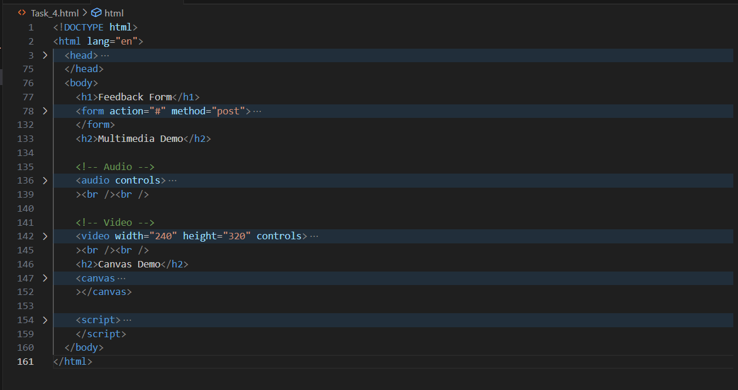

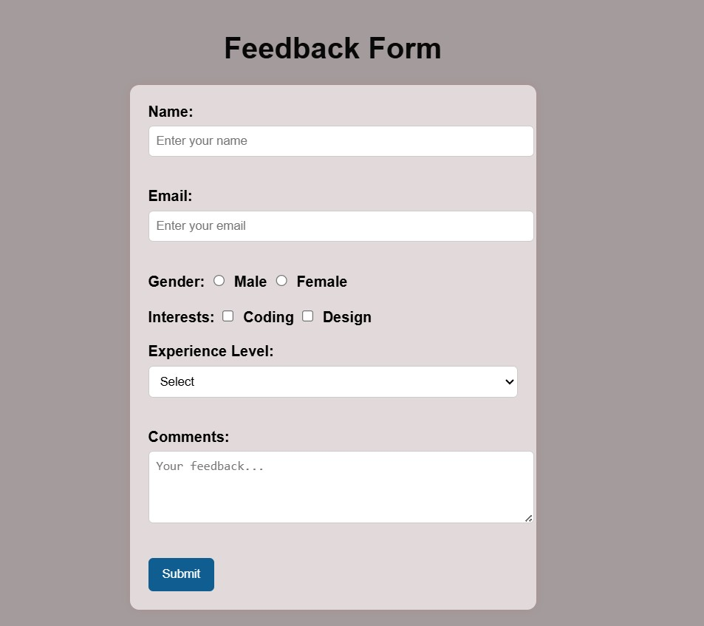

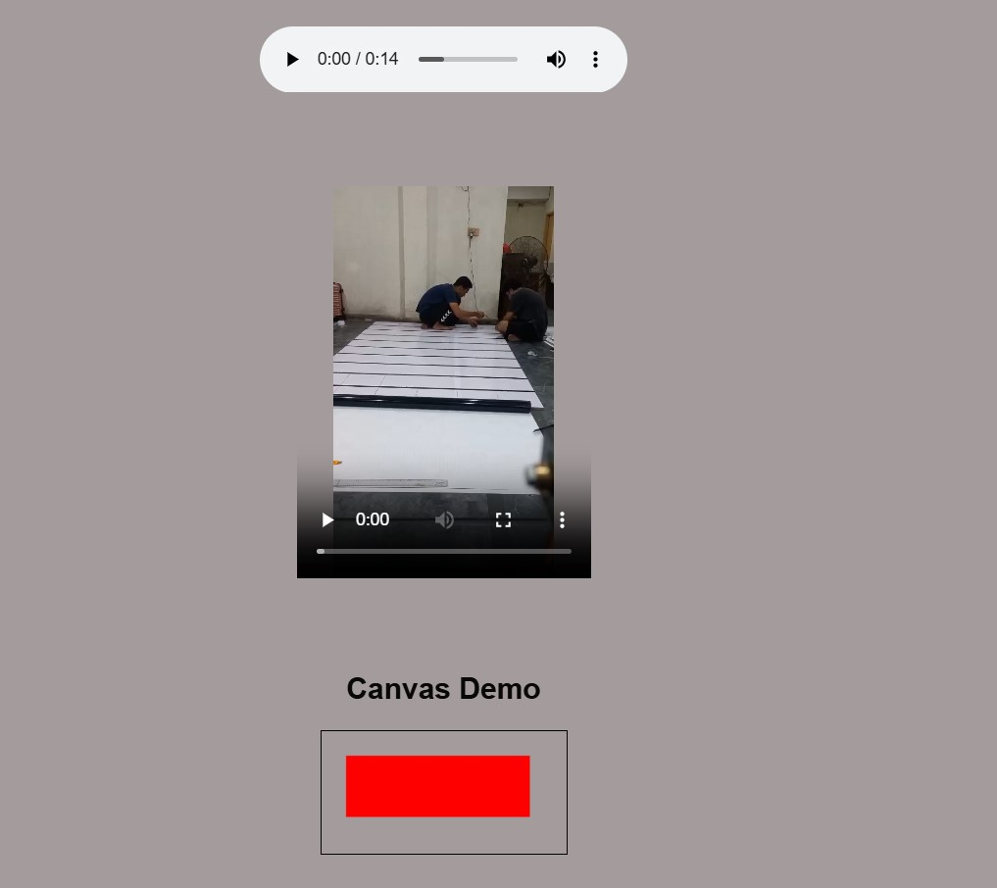

CONCLUSION:

In this lab, we created a simple web page with a feedback form, audio, video, and a canvas drawing. The form collects user information, the multimedia section plays audio and video, and the canvas shows a basic shape. This helped us learn how to use forms, multimedia, and canvas in HTML.

RUBRICS:

Performance |  |  | Lab Report
Description | Total Marks | Marks Obtained | Description | Total Marks | Marks Obtained
Ability to Conduct practical | 5 |  | Structure | 5
Data Analysis s Interpretation | 5 |  | Efficiency | 5

Total Marks obtained |  | Total Marks Obtained

Instructor Signature

